Remzi Tepe

21802713

CS223-05 LABORATORY WORK

LAB-02( 12.10.2020)

**Circuit Schematic for 2-bit Adder**

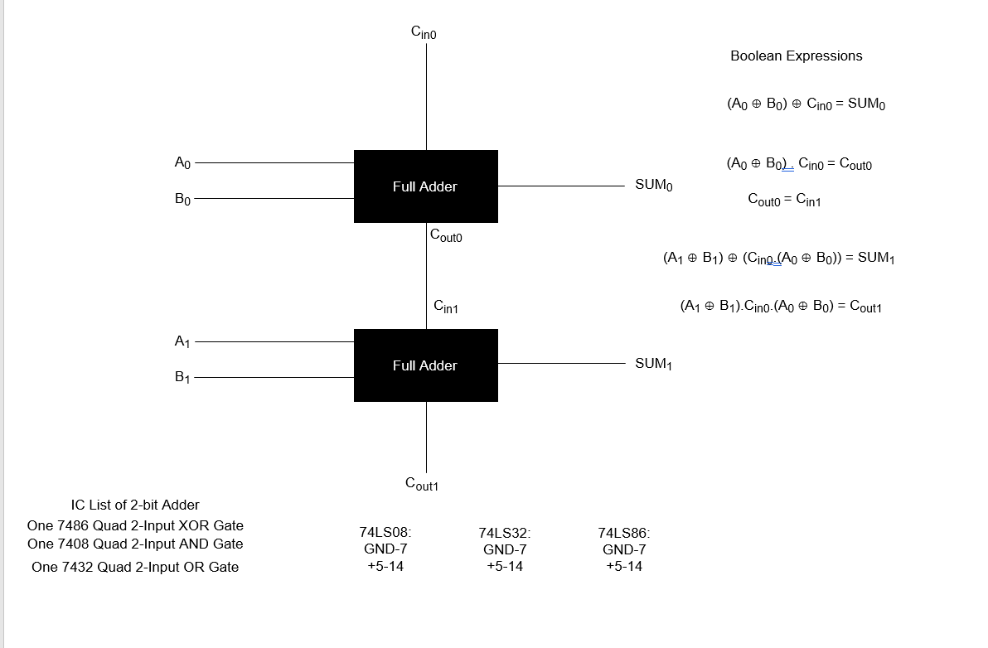

**Behavioral SystemVerilog module for Full Adder:**

module fullAdder (input logic a, b, cin,

output logic sum, cout);

assign sum = (a ^ b) ^ cin;

assign cout = (a^b) & cin | (a & b);

endmodule

**Structural SystemVerilog module for Full Adder:**

module xor2(input logic a, b,

output logic c);

assign c = a ^ b;

endmodule

module and2(input logic a, b,

output logic c);

assign c = a & b;

endmodule

module or2(input logic a, b,

output logic c);

assign c = a | b;

endmodule

module fullAdder(input logic a, b, cin

output logic sum, cout);

logic n1, n2, n3;

xor2 xorgate(a, b, n1);

xor2 xorgate2(n1, cin, sum);

and2 andgate(n1, cin, n2);

and2 andgate2(a, b, n3);

or2 orgate(n2, n3, cout);

endmodule

**Testbench for Full Adder:**

module testbenchAdder();

logic a, b, cin;

logic sum, cout;

fullAdder dut(a, b, cin, sum, cout);

initial begin

a = 0; b = 0; cin = 0; #10;

c = 1; #10;

b = 1; c = 0; #10;

c = 1; #10;

a = 1; b = 0; c = 0; #10;

c = 1; #10;

b = 1; c = 0; #10;

c = 1; #10;

end

endmodule

**Structural SystemVerilog module for Full Subtractor:**

module xor2(input logic a, b,

output logic c);

assign c = a ^ b;

endmodule

module and2(input logic a, b,

output logic c);

assign c = a & b;

endmodule

module or2(input logic a, b,

output logic c);

assign c = a | b;

endmodule

module inv(input logic a,

output logic b);

assign b = ~a;

module fullSubtractor(input logic a, b, bin

output logic d, bo);

logic n1, n2, n3, n4, n5;

xor2 xorgate(a, b, n1);

inv inv1(a,n2);

and2 andgate(n2, b, n3);

xor2 xorgate2(bin, n1, d);

inv inv2(n1, n4);

and2 andgate2(n4, bin, n5);

or2 orgate(n3, n5, bo);

endmodule

**Testbench for full Subtractor:**

module testbenchSubtractor();

logic a, b, bin;

logic d, bo;

fullSubtractor dut(a, b, bin, d, bo);

initial begin

a = 0; b = 0; bin = 0; #10;

bin = 1; #10;

b = 1; bin = 0; #10;

bin = 1; #10;

a = 1; b = 0; bin = 0; #10;

bin = 1; #10;

b = 1; bin = 0; #10;

bin = 1; #10;

end

endmodule

**Structural SystemVerilog module for 2-bit Adder:**

module fullAdder (input logic a, b, cin,

output logic sum, cout);

assign sum = (a ^ b) ^ cin;

assign cout = (a^b) & cin | (a & b);

endmodule

module 2bitAdder(input logic a0, b0, cin0, a1, b1, cin1

output logic sum0, cout0, sum1, cout1);

logic n1;

fullAdder fullAdder1(a0, b0, cin0, sum0, n1);

fullAdder fullAdder2(a1, b1, n1, sum1, cout1);

endmodule

**Testbench for 2-bit Adder:**

module testbench2bitAdder();

logic a, b, bin;

logic d, bo;

2bitAdder dut(a0, b0, cin0, a1, b1, cin1, sum0, cout0, sum1, cout1);

initial begin

a0 = 0; b0 = 0; cin = 0; a1 = 0; b1 = 0; #10;

b1 = 1; #10;

a1 = 1; b1 = 0; #10;

b1 = 1; #10;

cin = 1; a1 = 0; b1 = 0; #10;

b1 = 1; #10;

a1 = 1; b1 = 0; #10;

b1 = 1; #10;

b0 = 1; cin = 0; a1 = 0; b1 = 0; #10;

b1 = 1; #10;

a1 = 1; b1 = 0; #10;

b1 = 1; #10;

cin = 1; a1 = 0; b1 = 0; #10;

b1 = 1; #10;

a1 = 1; b1 = 0; #10;

b1 = 1; #10;

a0 = 1; b0 = 0; cin = 0; a1 = 0; b1 = 0; #10;

b1 = 1; #10;

a1 = 1; b1 = 0; #10;

b1 = 1; #10;

cin = 1; a1 = 0; b1 = 0; #10;

b1 = 1; #10;

a1 = 1; b1 = 0; #10;

b1 = 1; #10;

b0 = 1; cin = 0; a1 = 0; b1 = 0; #10;

b1 = 1; #10;

a1 = 1; b1 = 0; #10;

b1 = 1; #10;

cin = 1; a1 = 0; b1 = 0; #10;

b1 = 1; #10;

a1 = 1; b1 = 0; #10;

b1 = 1; #10;

end

endmodule